**University of Taipei**

**Exchange Program**

**Application Information**



**2020.02.01**

**Table of Contents**

Briefing of Exchange Program 1

Flow Chart for Exchange Program Procedure 2

Academic Year 3

Online Application 4

Basic Information of UT 6

Program Fees 8

List of Miscellaneous Fees 9

Tuition Fee for Visiting Student 10

Transportation 11

Easy Card for Travel 14

Related Information 15

Accommodation Information 16

VISA Information 20

Flow Chart of Visitor Visa Application 21

Flow Chart of Visitor Visa Extension 22

Authorization for Emergency Medical Treatment 23

Medical Examination Requirements for Short-Term Students（Form C） 25

# Briefing of Exchange Program

# Flow Chart for Exchange Program Procedure

# Academic Year

# Online Application

**The Link:** <http://exam.utaipei.edu.tw/ExchangeSystem/index.jsp>

|  |
| --- |
|  |
|  |
|  |

# Basic Information of UT

# Program Fees

# List of Miscellaneous Fees

|  |  |  |
| --- | --- | --- |
| Item | Amount | Description |
| Accommodation  Fee | NT$17,000  (US$550) | * According the different types of the rooms, the fee will depend on the choices. * As for the dorm allocation, we will arrange the four-person shared room mostly. * If the exchange student would like to change the room type, and the rooms are still available, the student should complete the changing process within one week after check-in. |
| Accommodation Deposit | NT$ 4000  (US$135) | * The exchange student pays in cash when he/she checks in. * The deposit will be refunded when the exchange student checks out. |
| Student ID Card | NT$210  (US$8) | * The exchange student pays in cash when he/she enrolls. * The payment should be made when the exchange student enrolls. |
| Internet Usage Fee | NT$1000  (US$33) |
| Swimming Pool Maintenance Fee | NT$150  (US$5) |
| Notice | * Exchange Students pay the tuition fee to the home institution. * Visiting Students pay the tuition fee to the UT. * The tuition fee for the visiting students is based on the college they enroll. | |

# Tuition Fee for Visiting Student

|  |  |  |  |
| --- | --- | --- | --- |
| College | Undergraduate  Program | Master  Program | PhD  Program |
| College of Education | NT$45,700  (US$1480) | NT$45,100  (US$1455) | NT$46,300  (US$1495) |
| College of Humanities and Arts | NT$45,700  (US$1480) | NT$45,100  (US$1455) | NT$46,300  (US$1495) |
| College of Science | NT$53,200  (US$1720) | NT$52,700  (US$1700) |  |
| College of Kinesiology | NT$53,550  (US$1730) | NT$54,000  (US$1745) | NT$54,000  (US$1745) |
| College of City Management | NT$53,550  (US$1730) | NT$54,000  (US$1745) | NT$54,000  (US$1745) |

**The Department of Music charges at the same rate as the College of Science.**

# Transportation

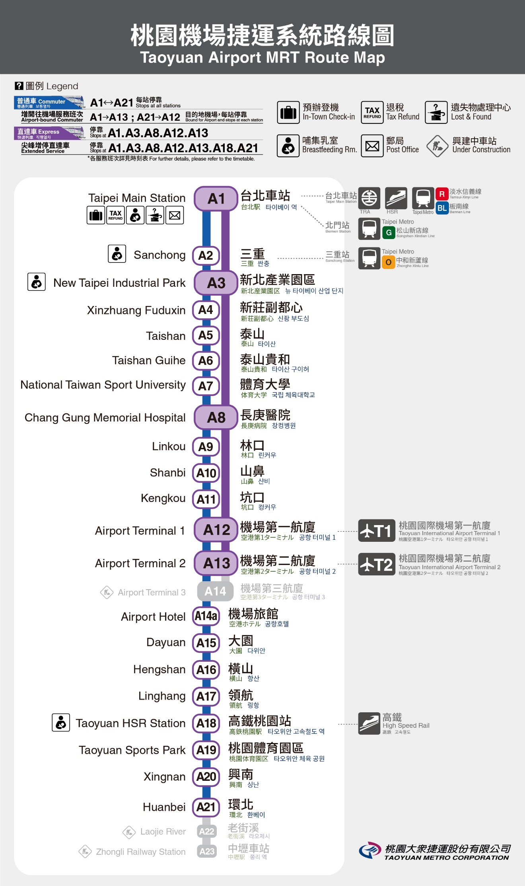

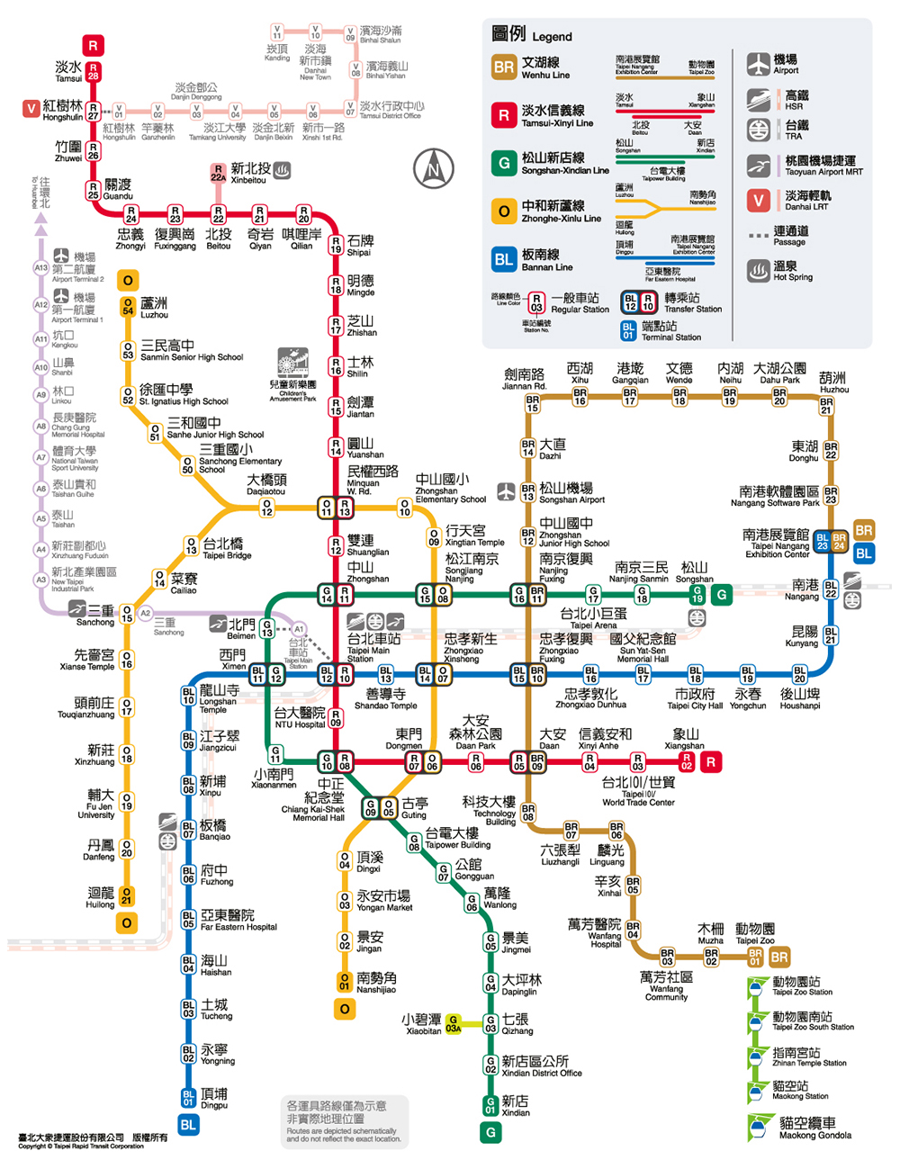

# Easy Card for Travel

# Related Information

# Accommodation Information

* **The exchange students are guaranteed to stay at the dorm.**
* **Address:** No.1, Lane 430, Fuxing N. Road., Zhongshan District, Taipei City 10476, Taiwan
* **Transportation:** Take MRT Wenhu Line (Brown Line) and get off at Zhongshang Junior High School Station. Then it takes ten minutes to walk.
* **Website:** [**http://international.utaipei.edu.tw/files/11-1035-6061.php?Lang=en**](http://international.utaipei.edu.tw/files/11-1035-6061.php?Lang=en)
* **Room Fee**

|  |  |
| --- | --- |
| **Type of Room** | **Room Fee/Per semester** |
| Two-person shared room  * Men-only and women-only rooms available | NT$**20,000**/person  (not incl. electric bill) |
| Three-person shared room  * Women-only rooms available | NT$**18,500**/person  (not incl. electric bill) |
| Four-person shared room  * Men-only and women-only rooms available | NT$**17,000**/person  (not incl. electric bill) |
| Six-person shared room  * Men-only and women-only rooms available | NT$**12,000**/person  (not incl. electric bill) |

* **As for the dorm allocation, we will arrange the four-person shared room mostly.** **If the exchange student would like to change the room type, and the rooms are still available, the student should complete the changing process within one week after check-in.**
* **Public Facilities:** Laundry facilities, Refrigerator, Bathroom, Internet, Lounge
* **Electricity Fee:** The exchange student has to buy a prepaid electricity card.
* **Deposit:** The exchange student has to pay the deposit and refund it when he/she checks out.

Explanation for the Payment in the International House

1. Deposit: NT$ 1,500
2. Electricity card deposit: NT$ 300

Electricity fee: NT$ 600

1. Laundry fee for bed sheets: NT$ 750

* First, the deposit NT$ 1500 will be refunded at the end of the semester if there is no damage caused by the tenant in the room or the hall.
* Second, the NT$ 900 is the sum of the NT$ 600 electricity fee and the NT$ 300 electricity card deposit. The NT$ 300 electricity card deposit will be refunded at the end of the semester. Based on the use of electricity, the remaining electricity fee will also be refunded at the end of the semester.
* Finally, the NT$ 750 laundry fee will not be refunded because it is supposed to be paid for bed sheet laundry.
* Please keep this receipt as the proof for refunds at the end of the semester.
* If anything in the room or in the hall is damaged by the tenant during this semester, the amount of compensation will be deducted from the deposit.
* **Photos**

|  |  |
| --- | --- |
|  |  |
|  |  |
|  |  |

# VISA Information

# Flow Chart of Visitor Visa Application

# Flow Chart of Visitor Visa Extension

# Authorization for Emergency Medical Treatment

I , (name of parent/guardian) understand that in the case of emergency of my child, (name), the University of Taipei in Taiwan will try to notify me or the person I have listed below as an emergency contact.

In case of a medical emergency concerning my child, at a time when I or my listed emergency contact, **for any reason, cannot be reached, I hereby grant with full power to the UT and its employees to act on my or my child’s behalf for the following treatments**:

1. Administer first aid.
2. Authorize a medical doctor to examine or treat my child.
3. Arrange for the transportation for my child, whether by ambulance or otherwise, to a proper facility where emergency medical treatment is normally administered, including but not limited to, an emergency room of a hospital, a doctor’s office, or a medical clinic.
4. Signed releases as may be required in order to obtain any medical or surgical treatment as is required in the judgment of medical authorities at the facility.

**I hereby agree to accept the financial responsibilities for any cost thus incurred in the treatment of any illness or accident.** I further agree that in the process of seeking or providing such treatment, neither the UT nor its employees shall be liable, de facto or de jure, for any complications that may arise thereof.

The following persons are appointed as my/our child’s Emergency Contact (if I/we cannot be reached):

Name: Email:

Cell:

Phone Number (H): Phone Number (O):

Name: Email:

Cell:

Phone Number (H): Phone Number (O):

Date:

Signature of Parent/Guardian:

Email：

Cell：

Phone Number (H): Phone Number (O):

The authorization comes into force upon legally-binding signature.

This information will be kept confidential in the possession of the university. Should the need arise, this information may be given to the proper medical authorities

|  |  |
| --- | --- |
| Medical Examination Requirements for Short-Term Students（Form C） | 檢查日期 ____/____/____  (年) (月) (日)  Date of Examination ____/____/____  **(**Ｍ) (Ｄ) (Ｙ) |

|  |  |  |  |  |  |  |  |  |  |  |  |  |  |  |  |  |  |  |  |  |  |  |  |  |  |  |  |  |  |  |  |  |  |  |  |  |  |  |  |  |  |  |  |  |  |  |  |  |  |  |  |  |  |  |  |  |  |  |  |  |  |  |  |  |  |  |  |  |  |  |  |  |  |  |  |  |  |  |  |  |  |  |  |  |  |  |  |  |
| --- | --- | --- | --- | --- | --- | --- | --- | --- | --- | --- | --- | --- | --- | --- | --- | --- | --- | --- | --- | --- | --- | --- | --- | --- | --- | --- | --- | --- | --- | --- | --- | --- | --- | --- | --- | --- | --- | --- | --- | --- | --- | --- | --- | --- | --- | --- | --- | --- | --- | --- | --- | --- | --- | --- | --- | --- | --- | --- | --- | --- | --- | --- | --- | --- | --- | --- | --- | --- | --- | --- | --- | --- | --- | --- | --- | --- | --- | --- | --- | --- | --- | --- | --- | --- | --- | --- | --- | --- |
| **基 本 資 料** (**Basic data)**   |  |  |  |  |  |  |  |  |  |  |  |  |  |  |  |  |  | | --- | --- | --- | --- | --- | --- | --- | --- | --- | --- | --- | --- | --- | --- | --- | --- | --- | | 姓 名 | |  | ： | |  | | | | |  | 性別 | ： | □男Male | | | □女Female | | Name | |  | ____________________ | | | | |  | Sex | |  | 國籍 | | | ： |  | | | | |  | 護照號碼 | | | ： |  | | |  | Nationality | | | ____________________ | | | | |  | Passport No. | | | ____________________ | | |  | 出生年月日 | | | ： | ––––– | / | ––––– | / | ––––– |  |  | | |  |  | | |  | Date of Birth | | |  |  | | |  | |     **檢　查 項 目 (Items required)**   |  | | --- | | **A. 麻疹及德國麻疹(風疹)之抗體陽性檢驗報告或預防接種證明（Proof of Positive Measles and Rubella Antibody Titers or Measles and Rubella Immunization Certificates）：**  a.抗體檢查Antibody Test  麻疹抗體Measles antibody titer □陽性 Positive □陰性 Negative □未確定（Equivocal）  德國麻疹(風疹)抗體Rubella antibody titer □陽性 Positive □陰性 Negative □未確定（Equivocal）  b.預防接種證明 Immunization Certificate (含疫苗名稱、接種日期、接種單位或醫師簽章。如檢附幼時接種紀錄，其接種年齡必須大於1歲。)  (The certificate must include information such as the date of immunization, and the name of the hospital or clinic administering the vaccine or the signature of the physician administering the vaccine. If the childhood immunization record is submitted, it is important to include the record of the vaccines administered only after one year of age.)  □麻疹預防接種證明Measles Immunization Certificate  □德國麻疹(風疹)預防接種證明Rubella Immunization Certificate  c. □經醫師評估，有接種禁忌者，暫不適宜接種。(Having contraindications, not suitable for vaccination) | | **B. 胸部X光檢查肺結核（ChestＸ-Ray for Tuberculosis）：**  X光發現(X-ray Findings)：  判定(Results)：  □合格(Passed) □疑似肺結核(TB Suspect) □須進一步診斷( Pending) □不合格(Failed)  □孕婦免驗 (Maternity Exemption) | |

備註(Note)：

一、本表為外籍學生、大陸及港澳地區學生來臺停留研修之健康檢查項目表。This form lists the required medical examination items for students applying for short-term study in Taiwan.

二、**根據以上對 先生/女士/小姐之檢查結果為**

**□合格 □不合格 □須進一步檢查**

**Results：According to the above medical report of Mr./Mrs./Ms. , he/she**

**□has passed the examination □has failed the examination □needs further examination.**

|  |  |  |  |
| --- | --- | --- | --- |
|  | ： |  | （Name ＆ Signature） |
| (Chief Medical Technologist) |
|  |  |  |  |
|  | ： |  | （Name ＆ Signature） |
| ( Chief Physician ) |
|  |  |  |  |
|  | ： |  | （Name ＆ Signature） |
| ( Superintendent ) |

日期（Date）： / /

**外 國 人 居（停）留 案 件 申 請 表**

**MULTIPLE-PURPOSE APPLICATION FORM FOR FOREIGNERS**

**申請日期(Date) (y) (m) (d) 請勾選申請項目(Check what you want to apply below)**

|  |  |  |  |  |  |  |  |  |
| --- | --- | --- | --- | --- | --- | --- | --- | --- |
|  | | | □**1居留證 ARC**□**2居留證延期ARC EXTENSION**□**3重入國RE-ENTRY PERMIT**□**4停留延期VISITOR VISA EXTENSION** □**5資料異動CHANGE OF INFORMATION**□**6居留證遺失/毀損LOST/ DAMAGED ARC**□**7永久居留APRC** □**8僑生OVERSEAS CHINESE STUDENT**□**9停留簽證改居留TRANSFER TO RESIDENT** □**10居留原因變更CHANGE OF RESIDENT PURPOSE**□11**旅行卡TRAVELLING CARD□12其他OTHER** | | | | | |
| **相 片PHOTO**(初/換/補發)最近1年內所拍攝、直４．５公分且橫３．５公分、脫帽、未戴有色眼鏡、五官清晰、不遮蓋、足資辨識人貌、人像自頭頂至下顎之長度不得小於３．２公分及超過３．６公分、白色背景之正面半身薄光面紙彩色照片，且不得修改或使用合成照片。【A thin half-length color photo with a glossy finish taken with a white background within the last one year that should be 4.5cm X 3.5cm with an image of the head that should not be shorter than 3.2cm or longer than 3.6cm from the top of the head to the chin, without wearing a hat or a pair of color glasses, with clear facial features not covered and identifiable, and should not be modified or composed.】 | | | **統一(居留)證號ID (ARC) No.：**| | |-| | | | | | | | | | | | | |
| **護照姓名**Full Name (in Capitals)： | | | | | |
| **中文姓名**Chinese Name： **國籍**Nationality：  **最高學歷**Education Degree:  **E-mail**： @ | | | | | |
| **1護照號碼**Passport No. **2護照效期**Expiry Date (Passport)  【 】 年/Y 月/M 日/D  **3出生日期**Date of Birth **4抵臺日期**Arrival Date (Latest)  年/Y 月/M 日/D 年/Y 月/M 日/D | | | | | □**單身**Single  □**結婚**Married  □**男**Male  □**女**Female |
| **申請事由1□依親2□就學3□工作 4□投資 5□傳教6□永居7□學術 8□商務9□其他**  Reason: 1**□**Dependent 2.**□**Study 3.**□**Work. 4. **□**Investment 5.**□**Missionary 6.**□**APRC 7.**□**Academy 8.**□**Business  9.**□**Other | | | | | | | **職業**Occupation **職位**Position | |
| **服務處所/就讀學校/依親對象/邀請單位/其他**  Employer/School / Dependent /Invitation Authority/Other： | | | | **在臺親友姓名**/ Relative’s/Friend’s Name in Taiwan:  **國籍**Nationality: | | | | |
|  | | | | **證號**ID： MCj02280530000[1]： | | | | |
| **居留地址Residential Address**： （市/縣City /County） （區/鄉/市/鎭District/Town） （路/街Rd./St.） （段Sec.） （巷Lane） （弄Alley） （號No.） （樓之F-.） | | | | | | | | |
| MCj02280530000[1]： | | |  | | | | | |
| **工作地址Office Address**： （市/縣City /County） （區/鄉/市/鎭District/Town） （路/街Rd./St.） （段Sec.） （巷Lane） （弄Alley） （號No.） （樓之F-.） | | | | | | | | |
| MCj02280530000[1]： | | |  | | | | | |
| **本人簽名Signature of Applicant：** **(本人未到請填下列授權)**  **我授權 代辦上述事項/I hereby authorize to make the aforesaid application.**  **被委託人簽名：Signature of Agent: 證號ID N0. MCj02280530000[1]：** | | | | | | | | |
| **注意事項請參考背面/Please read instructions on reverse. |以下請勿填寫/For Authorized Staff Only↓** | | | | | | | | |
| **證 明**  **文 件** | ______年______月______日（□勞職規）（□中研院）（□投審會）（□國科會）（ ）字  第 號、許可效期 年 月 日~ 年 月 日  □在職證明□戶籍謄本□戶口名簿□身分證□健康檢查證明□刑事紀錄證明□出生證明□法院收養裁定書□結婚證書□單身證明□在學證明□出席紀錄□註冊學生證□學籍證明□新護照□新租約□外僑居留證□收件回條□立案/法人登記證明□宗教邀請函□韓僑身分證明□僑輔室同意書□離職證明□公司變更事項登記表□董監事名冊□投資備查函□商業司許可函□外國公司認許表□外國分公司設立登記表□營利事業登記證□外交部專案核准公函□其他： | | | | | | | |
| **居留證**  □初 □延 | | 居留證號碼：| | |-| | | | | | | | | **收據號碼：**  **居留期限：** 年 月 日~ 年 月 日 **收據號碼：** | | | | | | |
| □**重入國** | | □單次 □多次/許可證號： |有效期限： 年 月 日 | | | | | | |
| □**資 料**  **異 動** | | □1護照號碼□2居留地址□3公司名稱□4公司地址□5電話號碼□6遺失補發□7毀損補發□8換證-曾領證□9蓋滿□10加註工作□11改中(英)文名□12 | | | | | | |
| □**停留延期** | | 核准事由：□1探親□2學中文□3傳教□4工作□5收件回條□6  **簽證字號：** **E/D卡號：**  1： 年 月 日2： 年 月 日3： 年 月 日4： 年 月 日 | | | | | | |
| **核准編號**  【 】 | |
| **旅行卡**  **□商務□學術**  **□初辦□重辦** | | 證號：| | |-| | | | | | | | | 資料登錄傳送日期： 年 月 日  審核機關：□中央目的事業主管機關 □外交部領事事務局 審核結果：□同意 □不同意  **隨行親屬 人。核准期限：** 年 月 日~ 年 月 日 | | | | | | |
| 夫妻雙方已接受臨櫃面談（The couple have been interviewed.）  申請人簽名Signature of **Applicant：**  配偶簽名Signature of Mate： | | | | | **承辦人員** | **審核人員** | | **建檔人員** |
| / / |  | | / / |
| 停留簽證延期  Application Information for Visitor Visa Extension  Receiving Unit承辦單位 : Local Immigration Service Center of Applicant’s Residence Address only**限申請人居住地服務站辦理**)**※※**  **Notices:注意↓※**  1-The duration of stay is calculated from the next day of arrival.停留期限自入境翌日起算。  2-Those with landing visa or visa-exemption entry, cannot apply for extension.以落地簽證或免簽入境者，不得申請延期。  3-Those needing to extend for valid reasons, should apply for extension within 15 days before the duration of visa expired. Each extension must not exceed the originally permitted time on the visa. The cumulative length of stay must not exceed 180 days.有合理理由需延期者，應於簽證停留期限到期前15日內申請延期。每次延期期限不得逾原簽證之停留期限。總累計停留期間不得超過180日。  4-Table of Visa Codes簽證代碼:Please check it on the website of BOCA.請至外交部領務局網站查詢。  CODE-A :Employment CODE-TR :Changing a visitor visa to a resident visa  CODE-P :Touring, visiting relatives CODE-TS :Foreign spouses  CODE-B :Business CODE-FR :Studying Chinese CODE-R :Religious CODE-FC :Overseas Chinese students CODE-FS :Foreign students | | | | | 初辦居留證或延期  Application Information for Alien Resident Certificate Receiving Unit承辦單位 : Local Immigration Service Center of Applicant’s Residence Address only**限申請人居住地服務站辦理**)**※**  **Notices:注意↓※**  1- Foreigners holding resident visa or changing to resident visa should go to local immigration service center to apply for alien resident certificates within 15 days counted from the next day of arrival or the next day of receiving resident visa in Taiwan. (Otherwise, the penalty will be NT$2,000-10,000.)持居留簽證入境或於境內獲發居留簽證者，應於入境或取得居留簽證後15日內，至居留地服務站申辦居留證(否則罰鍰為新臺幣2,000至10,000元)。  2- Operation Fee:規費  1 year term: NT$1,000一年期新臺幣1,000元 2 year term: NT$2,000二年期新臺幣2,000元 3 year term: NT$3,000三年期新臺幣3,000元  Overseas Chinese students: NT$500僑生一年期新臺幣500元 Lost or Damaged ARC : NT$500遺失或毀損新臺幣500元  3- Updating data(Change of information):更新資料  Aliens who have changed their residence address or employer (or working place) shall register the change with related documents at the local immigration service center within 15 days.(Otherwise, the penalty will be NT$2,000-10,000.).變更居留地址或服務處所應於15日內備妥文件辦理異動,否則罰鍰NT:2,000-10,000 | | | |
| Required documents所需文件: (Original is necessary for **a**pplication.正本文件是必備的)國外文件需經我國駐外館處認證始得在國內使用. Documents issued outside of Taiwan MUST be translated into Chinese, and certified by the ROC Embassy, Consulate, or Trade Office abroad.  A- An application form申請書一份。  B- Passport (original to be returned after verification)護照(正本驗畢歸還)。  C-Visiting family:探親(original and photocopy正本與影本)。  1- Household registration transcript issued within 3 months, or Alien Resident Certificate (original and photocopy )3個月內依親對象戶籍謄本或居留證。  2- Proof of family relationship (such as marriage certificate, birth certificate with parents’ information, etc.) (original and photocopy )親屬關係證明(如結婚證書、具父母資料之出生證明…等).  D- Studying Mandarin language (The extension must be done in person.)學中文者本人需親自到場(original and photocopy正本與影本)：  1- Proof of registration and class schedule from an approved university language center在學證明  2- Attendance records (The first time extension does not need to hand in the attendance records.) (original-within 3 months before)3個月內出席紀錄  E- Doing missionary work:傳教(original and photocopy正本與影本)  1- Invitation letter or relevant certificates from religious organization in Taiwan(original within 1 month)1個月內邀請函  2- Copy of proof of religious organization’s registration立案證書或法人登記證書  F- Those accepting employment:應聘工作 (original and photocopy正本與影本)  1- Approval letter from authorized government agent.(work permit)工作許可函  2- employment certificate(original, within 1 month )1個月內在職證明正本  G-Others:其他(original and photocopy正本與影本)  1-Approval letter from authorized government agent.政府機關許可函. | | | | | Required documents所需文件: (Original is necessary for application) (正本文件是必備的)國外文件需經我國駐外館處認證始得在國內使用. Documents issued outside of Taiwan MUST be translated into Chinese, and certified by the ROC Embassy, Consulate, or Trade Office abroad.  A- An application form & 1 photos.申請書 & 相片1張  B- Passport and resident visa (original and photocopy )護照及居留簽證(original and photocopy正本與影本)  C- Those visiting family:依親(original and photocopy正本與影本)  1-Household registration transcript issued within 3 months, or Alien Resident Certificate 3個月內依親對象戶籍謄本或居留證(original and photocopy正本與影本)  2- Proof of family relationship (such as marriage certificate, birth certificate with parents’ information, etc.)親屬關係證明(如結婚證書、具父母資料之出生證明…等) (original and photocopy正本與影本)  D- Studying Mandarin language (The extension must be done in person.)學中文者本人需親自到場(original and photocopy正本與影本)：  1- Proof of registration and class schedule from an approved university language center在學證明  2- Attendance records (The first time extension does not need to hand in the attendance records.) (original-within 3 months before)3個月內出席紀錄  E- Doing missionary work:傳教 (正本與影本)  1- Invitation letter or relevant certificates from religious organization in Taiwan(original within 1 month)1個月內邀請函  2- Copy of proof of religious organization’s registration立案證書或法人登記證書  F- Those accepting employment:應聘工作 (original and photocopy正本與影本)  1- Approval letter from authorized government agency (work permit)工作許可函  2- employment certificate(original, within 1 month )1個月內在職證明正本  3-NEW JOB—PLEASE SEE H↓換新工作看下方H↓  G-Others: 其他 (original and photocopy正本與影本)  1- Approval letter from authorized government agency政府機關許可函(original and photocopy正本與影本)  H- Updating data:資料異動(original and photocopy正本與影本)  1- Changing a new employer：a new work permit, new employment certificate within 1 month and termination of employment certificate換工作-新工作許可函、在職證明和離職證明.  2-Changing resident address：proof of new address(such as a new lease, a new household registration, etc.) 換新居留地址-新地址證明(如租約或新戶籍謄本…等等)  I-外商在臺分公司之訴訟及非訴訟代理人The litigation/ non-litigation agent for the branch office of a foreign company  1-經濟部核准之認許公函The approval letter from Ministry of Economic Affairs  2-營利事業登記證.公司變更登記事項卡.董事名冊The Business License, Corporate Amendment Registration Card and the Roster of Director  1- working place：new work permit and new employment certificate and termination certificate換工作-新工作許可函.在職證明和離職證明.  2- residence address：proof of new address(such as a new lease, a new household registration, etc.) 換新居留地址-新地址證明(如租約或新戶籍謄本…等等) | | | |
| Application Information for Alien Permanent Resident Certificate (APRC)永久居留:Please go to our web site : <http://www.immigration.gov.tw>  OR contact with the local immigration service center directly.  請參閱移民署網站或直接聯絡居住地服務站. | | | | |
| If you have any question about ‘VISA’ please contact BOCA.  簽證問題請逕洽外交部領事事務局 <http://www.boca.gov.tw> TEL-02-23432885 臺北市濟南路一段2-2號3-5樓3~5 Fl., 2-2 Chi-Nan Rd., Sec. 1, Taipei , Taiwan, ROC | | | | |
| 內政部移民署NATIONAL IMMIGRATION AGENCY  100-66臺北市中正區廣州街15號No15 Guang jhou St. Jhongjheng district Taipei City Taiwan 100-66  <http://www.immigration.gov.tw/> TEL：23889393  **表格下載可直接到移民署網站** | | | | |